create database as_zomato;

use as_zomato;

CREATE TABLE goldusers_signup

(userid int,gold_signup_date date);

INSERT INTO goldusers_signup

(userid,gold_signup_date)

VALUES (1,'2017-09-22'),

(3,'2017-04-21');

select * from goldusers_signup;

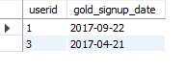

CREATE TABLE users

(userid int,signup_date date);

INSERT INTO users(userid,signup_date)

VALUES (1,'2014-09-02'),

(2,'2015-01-15'),

(3,'2014-04-11');

select * from users;

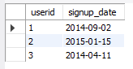

CREATE TABLE sales

(userid int,

created_date date,

product_id int);

INSERT INTO sales(userid,created_date,product_id)

VALUES (1,'2017-04-19',2),

(3,'2019-12-18',1),

(2,'2020-07-20',3),

(1,'2019-10-23',2),

(1,'2018-03-19',3),

(3,'2016-12-20',2),

(1,'2016-11-09',1),

(1,'2016-05-20',3),

(2,'2017-09-24',1),

(1,'2017-03-11',2),

(1,'2016-03-11',1),

(3,'2016-11-10',1),

(3,'2017-12-07',2),

(3,'2016-12-15',2),

(2,'2017-11-08',2),

(2,'2018-09-10',3);

select * from sales;

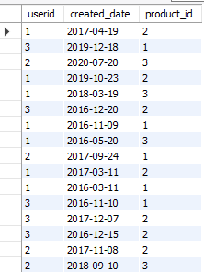

CREATE TABLE product

(product_id int,

product_name text,

price int);

INSERT INTO product

(product_id,product_name,price)

VALUES

(1,'p1',980),

(2,'p2',870),

(3,'p3',330);

select * from product;

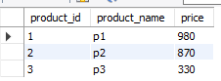

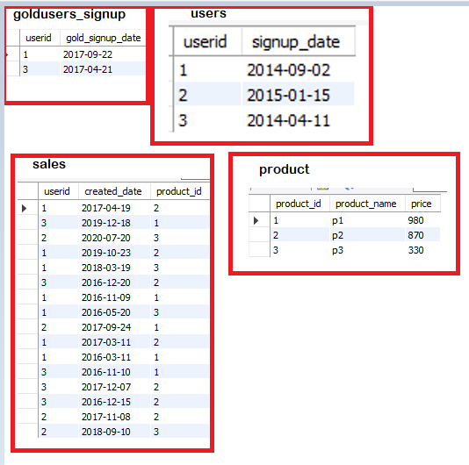

Questions:

1.what is total amount each customer spent on zomato ?

First take inner join of sales and product

select * from sales s inner join product p on

s.product_id = p.product_id;

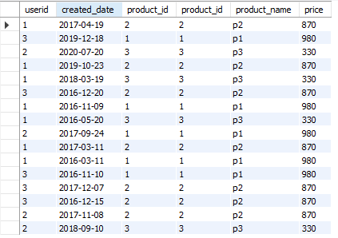

select * from sales s inner join product p on

s.product_id = p.product_id order by s.userid;

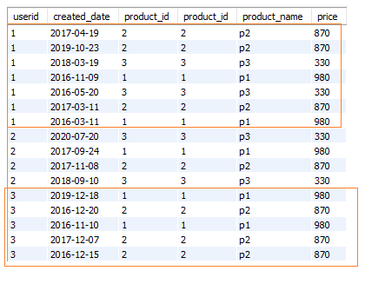

select s.userid, sum(p.price) from sales s inner join product p on

s.product_id = p.product_id

group by s.userid;

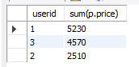

select s.userid, sum(p.price) as total_amt_spent

from sales s inner join product p on

s.product_id = p.product_id

group by s.userid;

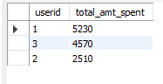

2.How many days has each customer visited zomato?

Distinct days customer visited zomato.

select userid, count(distinct created_date) as days_visited from sales

group by userid;

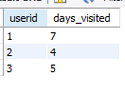

3. Which was the first product purchased by each customer?

Date needs to considered as the oldest. So need to order the date

select *, rank() over

(partition by userid order by created_date) as rnk

from sales;

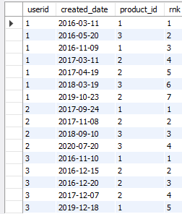

select * from

(select *, rank() over

(partition by userid order by created_date) as rnk

from sales) a where rnk = 1;

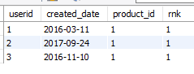

Extra:

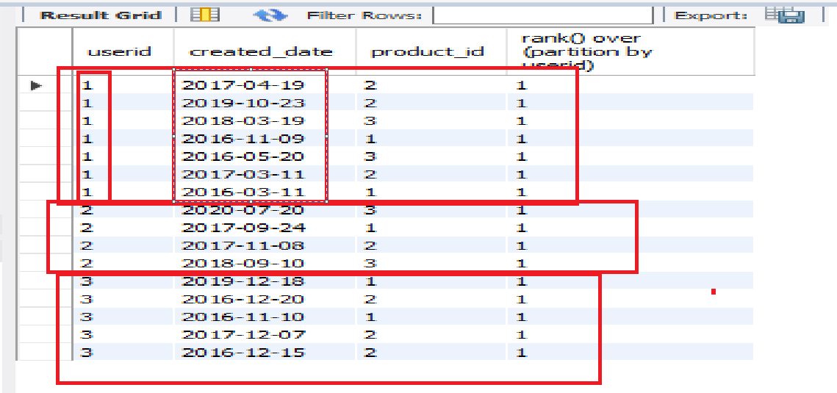

select *,

rank() over

(partition by userid)

from sales;

Final Query:

select p1.userid, p2.product_name from   
 ( select * from (select *,   
rank() over   
(partition by userid   
order by created_date asc) as rnk  
from sales) p  
where rnk = 1) p1 inner join product p2 on p1.product_id=p2.product_id;

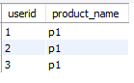

4. Which is the most purchased item on menu & how many times was it purchased by all customers ?

Most purchased products

select product_id, count(product_id) from sales

group by product_id;

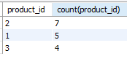

select product_id, count(product_id) from sales

group by product_id order by count(product_id) desc;

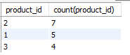

Product_id 2 is the highly bought product.

Display one 1 product highly bought

select product_id, count(product_id) as cnt from sales

group by product_id order by count(product_id) desc limit 1;



Only display the product_id

select product_id from sales

group by product_id order by count(product_id) desc limit 1;



Now, how many times product_id 2 was purchased by all customers

select * from sales

where product_id = (select product_id from sales

group by product_id order by count(product_id) desc limit 1);

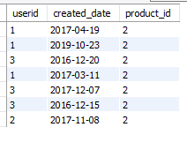

select userid, count(product_id) as cnt from sales

where product_id = (select product_id from sales

group by product_id order by count(product_id) desc limit 1)

group by userid;

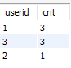

FINAL QUERY

select userid, product_id, count(product_id)

from sales where product_id= (select product_id from sales

group by product_id order by count(product_id) desc limit 1)

group by userid, product_id;

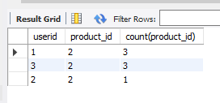

5.which item was most popular for each customer?

Sales

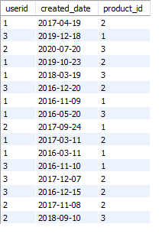

select userid, product_id,

count(product_id) from sales group by userid, product_id;

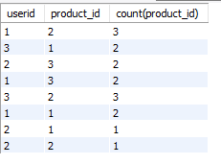

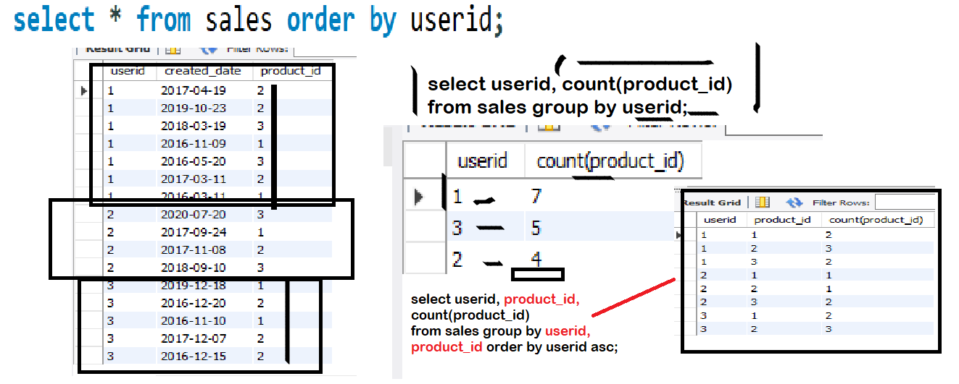

Use partition

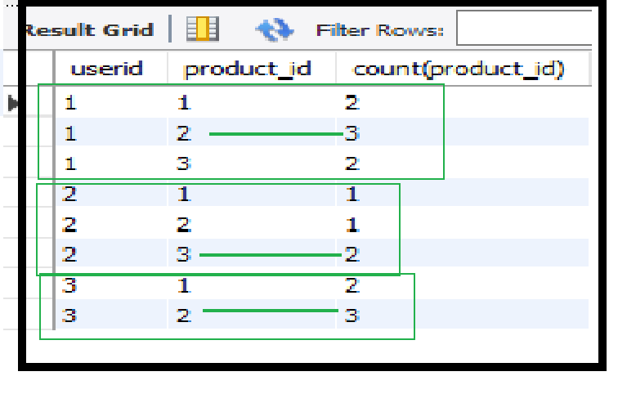

select *, rank() over

(partition by userid order by cnt desc) as rnk

from

(select userid, product_id,

count(product_id) as cnt from sales group by userid,product_id) a;

Here, a is name of the derived table

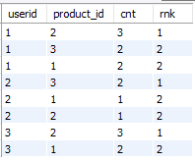

select * from

(select *, rank() over (partition by userid order by cnt desc) as rnk

from (select userid, product_id, count(product_id) as cnt from sales group by userid,product_id) a)b

where rnk=1;

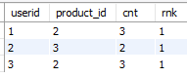

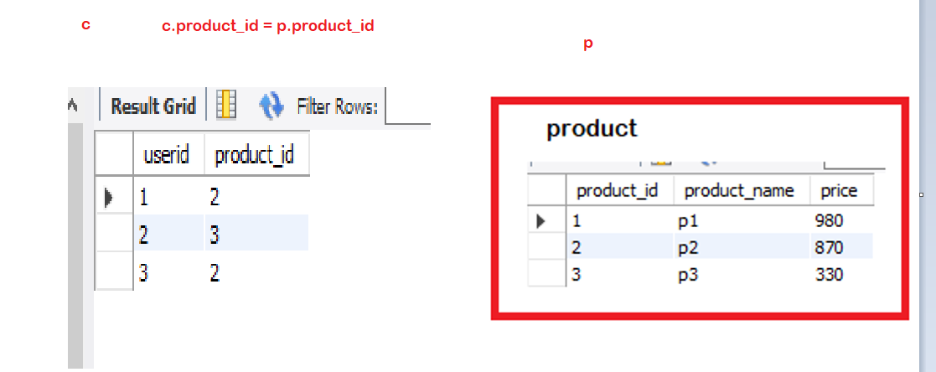

select c.userid, c.product_id, p.product_name from

(select userid, product_id from (select *, rank() over

(partition by userid order by cnt desc) as rnk

from

(select userid, product_id,

count(product_id) as cnt

from sales group by userid,product_id) a) b where rnk= 1) c

inner join product p

on c.product_id = p. product_id;

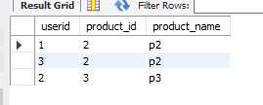

6. Which item was purchased first by customer after they become a member ?

First only retrieve the members having gold membership

select a.userid, a.created_date, a.product_id,

b.gold_signup_date from

sales a inner join goldusers_signup b

on a.userid = b.userid;

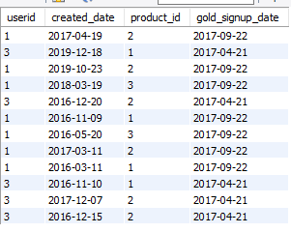

select * from

(select a.userid, a.created_date, a.product_id,

b.gold_signup_date from

sales a inner join goldusers_signup b

on a.userid = b.userid) p where created_date > gold_signup_date;

select a.userid, a.created_date, a.product_id,

b.gold_signup_date from

sales a inner join goldusers_signup b

on a.userid = b.userid and created_date >= gold_signup_date;

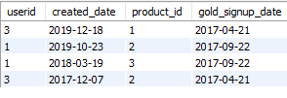

select c.*, rank() over (partition by userid order by created_date) rnk from

(select a.userid, a.created_date, a.product_id,

b.gold_signup_date from

sales a inner join goldusers_signup b

on a.userid = b.userid and created_date >= gold_signup_date) c;

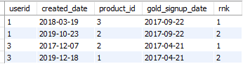

select * from

(select c.*, rank() over (partition by userid order by created_date) rnk from

(select a.userid, a.created_date, a.product_id,

b.gold_signup_date from

sales a inner join goldusers_signup b

on a.userid = b.userid and created_date >= gold_signup_date) c) d where rnk =1;



FINAL QUERY

select e.userid, e.created_date, e.product_id,

p.product_name from

(select * from (select c.*, rank() over

(partition by userid

order by created_date asc) rnk from

(select s.userid, s.created_date,

s.product_id, p.gold_signup_date from

sales s inner join goldusers_signup p

on s.userid = p.userid and

s.created_date >= p.gold_signup_date) c) d where rnk = 1) e inner join product p

on e.product_id = p.product_id;

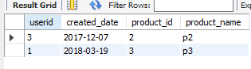

7. which item was purchased just before the customer became a member?

select * from

(select c.*, rank() over (partition by userid order by created_date desc) rnk from

(select a.userid, a.created_date, a.product_id,

b.gold_signup_date from

sales a inner join goldusers_signup b

on a.userid = b.userid and created_date <= gold_signup_date) c) d where rnk =1;

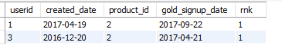

8. what is total orders and amount spent by each member before they become a member?

Details of members before they get a gold membership

select a.userid, a.created_date, a.product_id,

b.gold_signup_date from

sales a inner join goldusers_signup b

on a.userid = b.userid and created_date <= gold_signup_date;

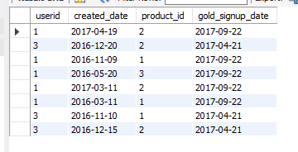

Now assume above table as c. We need to get the price associated with above products. So take an inner join of above table c with product table.

select c.*, d.price from

(select a.userid, a.created_date, a.product_id,

b.gold_signup_date from sales a inner join goldusers_signup b

on a.userid = b.userid and created_date <= gold_signup_date) c inner join product d

on c.product_id = d.product_id;

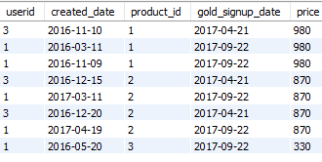

select c.*, d.price from

(select a.userid, a.created_date, a.product_id,

b.gold_signup_date from sales a inner join goldusers_signup b

on a.userid = b.userid and created_date <= gold_signup_date) c inner join product d

on c.product_id = d.product_id order by userid;

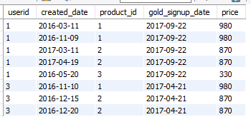

Now from above table, count the number of orders purchased by each customer and also give total price by grouping the userid.

select userid, count(created_date) as count_of_purchased_orders,

sum(price) as total_amt_spent from

(select c.*, d.price from

(select a.userid, a.created_date, a.product_id,

b.gold_signup_date from sales a inner join goldusers_signup b

on a.userid = b.userid and created_date <= gold_signup_date) c inner join product d

on c.product_id = d.product_id)e

group by userid;

